Developed functions for M8190A

# Developed GUI for Signal Upload

iqSignalUpload.fig and iqSignalUpload.m

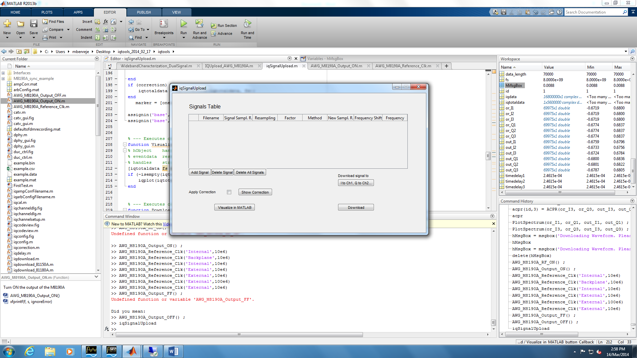

The user add the signal to Upload to AWG by specifying the File Path in the File name cell, the signal sampling rate, state if resampling is required and the sampling factor and the method of resampling (interpolation or fft) and state if a frequency shift is needed and the value of the shift.

The user can see the signal characteristics before downloading to the instrument by clicking on Visualize in MATLAB.

The user can specify the channels configuration then download the signal to the connected instrument.

An amplitude correction could be applied to the signal which is saved in the file ampCorr.mat.

# Developed functions to be used separately

function AWG_M8190A_SignalUpload(SignalsCell, CarrierFreqCell, SampleFreqCell, SampleFreqAWG, CorrectionEnabled)

% Upload one or several signals to the configured AWG

% - SignalsCell - cell of complex signals that needs to be sent

% - CarrierFreqCell - cell of carrier frequency values to which signals will be

% upconverted

% - SampleFreqCell - cell of sampling frequency values of each signal

% - SampleFreqAWG - Sample Frequency of the M8190A. Value should be between

% 125e6 and 8e9 for Version 14Bits and 125e6 and 12e9 for Version 12Bits

% - CorrectionEnabled - logical value for enabling the amplitude correction

% saved in the ampCorr.mat

function AWG_M8190A_Output_ON(Channel)

% Turn ON the output of the M8190A

% Channel - Specify the channel to be set (1 or 2)

function AWG_M8190A_Output_OFF(Channel)

% Turn OFF the output of the M8190A

% Channel - Specify the channel to be set (1 or 2)

function AWG_M8190A_Reference_Clk(IntorExt,ClkFreq)

% Configure the Refernce Clock of the M8190A

% IntorExt - Set the reference clock source for 'Internal', 'External',

% 'Backplane' (Default)

% ClkFreq - Specify the clock frequency of the external clock source

function AWG_M8190A_DAC_Amplitude(Channel,Amplitude)

% Configure the DAC Amplitude for the M8190A

% Channel - Specify the channel to be set (1 or 2)

% Amplitude - Voltage Amplitude (between 0.1 and 0.7 V)

function AWG_M8190A_MKR_Amplitude(Channel,Amplitude)

% Configure the Sample Marker Amplitude for the M8190A

% Channel - Specify the channel to be set (1 or 2)

% Amplitude - Voltage Amplitude (between 0 and 1.5 V)